**JAVA & SELENIUM PRE CLASS SOFTWARE INSTALLATION**

JAVA INSTALLATION

**Check for the availability of JAVA in your system**

• To check go to the run -> command prompt or terminal and type java -version (java<space>-version)

*2. -* If you do not have JAVA, you will receive this error message

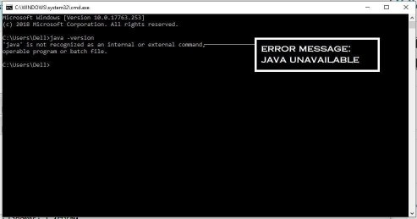

*3. -* If Java already available in your system, you can find the available version of

**Note!** If you already have JAVA in your system, we recommend you to have a course

*3. –* If

Java already available in your system, you can find the available version of

3. If Java already available in your system, you can find the available version of the Java

Note: If you already have Java in your system, we recommend you to have a course compatible version **i.e JAVA 1.8.x**

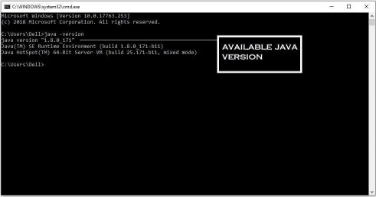

Follow steps to install JAVA:

**Make sure that you have a decently configured PC and well connected Internet during the installation and course.**

1. Navigate to any of your local drives and create a folder named GERP.
2. If you have 32 bit operating system, download the Eclipse 32 bit folder to your

JDK Installation

You can find the installation file from the downloaded content. Depends on your

Now go to this https://drive.google.com/drive/u/0/folders/1uqnfK_28GKj3zgoXdlfhtdptAyHC4lkV

and download the jdk-8u271-windows-x64.exe (for 64 bit system) and install it.

Environment path setting ( Not required

Environment path setting

• Go to this Path in your computer: **Control Panel\System and Security\System**

• Click on “**Advanced system settings**” and click on **Environment Variables**

• **Add the Java path in the Path variable under the System Variables E.g.: C:\Program Files\Java\jdk1.8.0\bin**

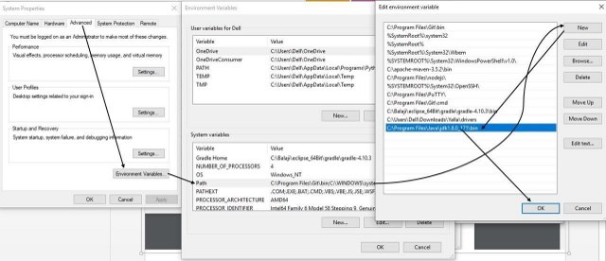

On successful completion of JDK installation, go to command prompt / terminal and type java version

Eclipse Installation

**Pre-Requisite/Note:**

* JDK 1.8 should be installed prior to the Eclipse installation
* You can as well follow using this URL *http://www.tech-recipes.com/rx/39279/*
* You can download Eclipse from URL[*https://www.eclipse.org/downloads/*](https://www.eclipse.org/downloads/) *and extract eclipse IDE for Java Developers*

Once extracted, go inside the extracted folder and click on eclipse application.

[Eclipse does not require installation, just copying the given folder will enable you to

use Eclipse] Choose the convenient work-space(Project Path this can be of any path) and click ok

<https://www.eclipse.org/downloads/packages/installer>

 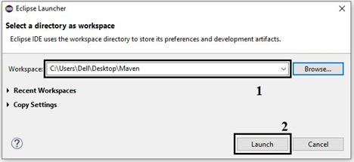

**Note**: Go to the downloaded software folder given by and go to software’s

Maven Project Setup

• Close the welcome tab

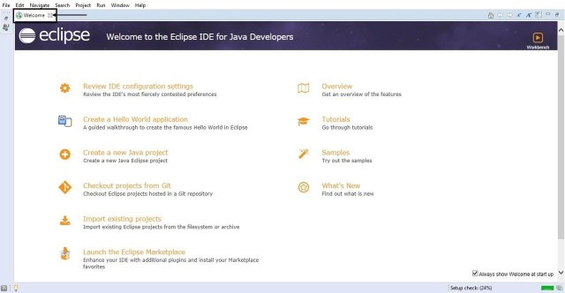

• Click on **File -> New -> Project**

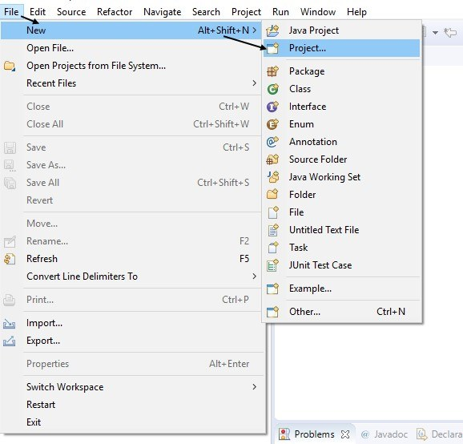

• Click **Maven -> Maven Project -> Next.**

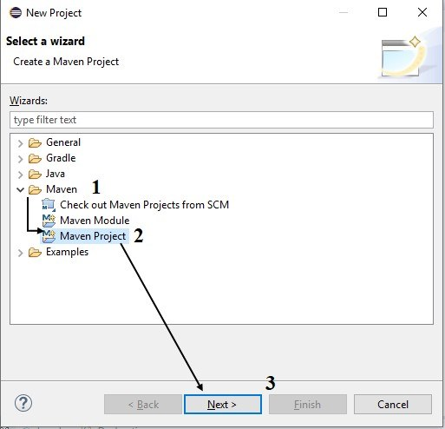

• Check the checkbox in 1 to add a simple project and click next.

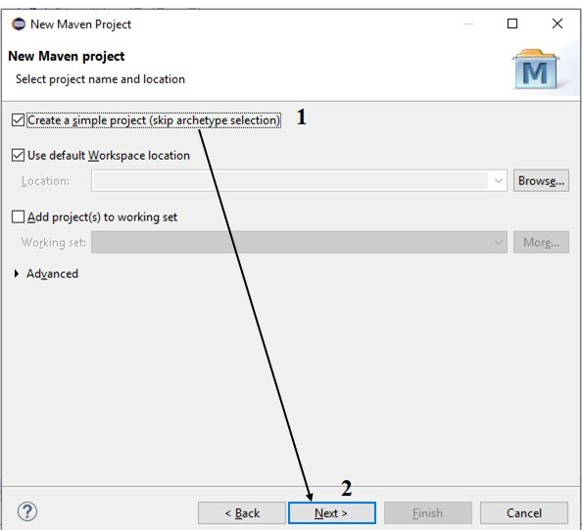

• Enter **Group ID** and **Artifact ID** and click **finish**.

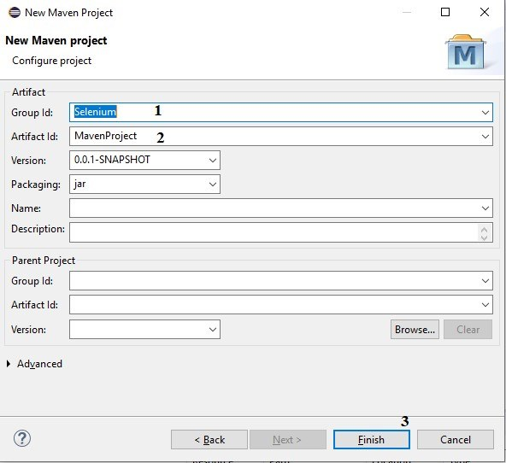

• Wait till the project is created.

• After completion, you will find the following hierarchy in your eclipse project explorer.

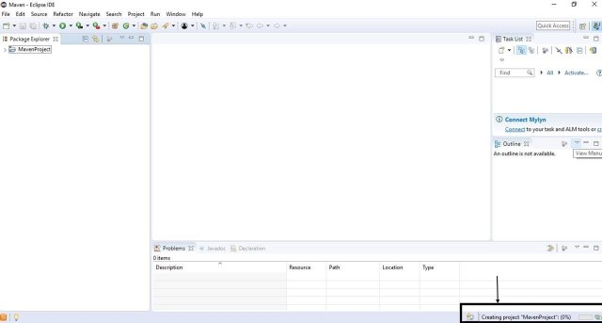

• Click Pom.xml in package explorer then click pom.xml.

• Click Pom.xml in package explorer then click pom.xml.

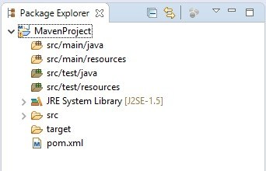

• Now copy the dependencies from pom.xml.txt that is in Maven Dependencies in

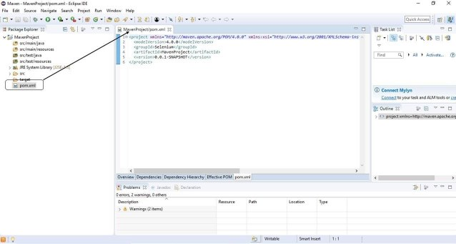

• Now copy the dependencies from pom.xml.txt that is in Maven Dependencies in

• Now copy the Selenium Java dependencies from <https://mvnrepository.com/artifact/org.seleniumhq.selenium/selenium-java/4.1.3> and paste after the **</version>** . Then save the file (Below is the copy paste of the 4.1.3 version dependencies for reference)

<dependencies>

<dependency>

<groupId>org.seleniumhq.selenium</groupId>

<artifactId>selenium-java</artifactId>

<version>4.1.3</version>

</dependency>

## Now copy the [WebDriverManager](https://mvnrepository.com/artifact/io.github.bonigarcia/webdrivermanager) dependencies from <https://mvnrepository.com/artifact/org.seleniumhq.selenium/selenium-java/4.1.3> and paste after the </version> . Then save the file (Below is the copy paste of the 5.1.1 version dependencies for reference)

<dependency>

<groupId>io.github.bonigarcia</groupId>

<artifactId>webdrivermanager</artifactId>

<version>5.1.1</version>

</dependency>

</dependencies>

</project>



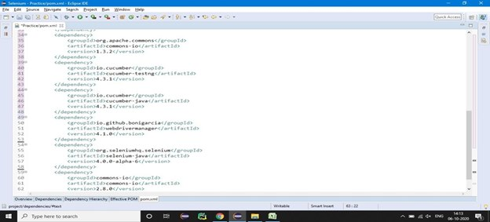

• Right click on the **project** and move to **Maven** then select **update project**.

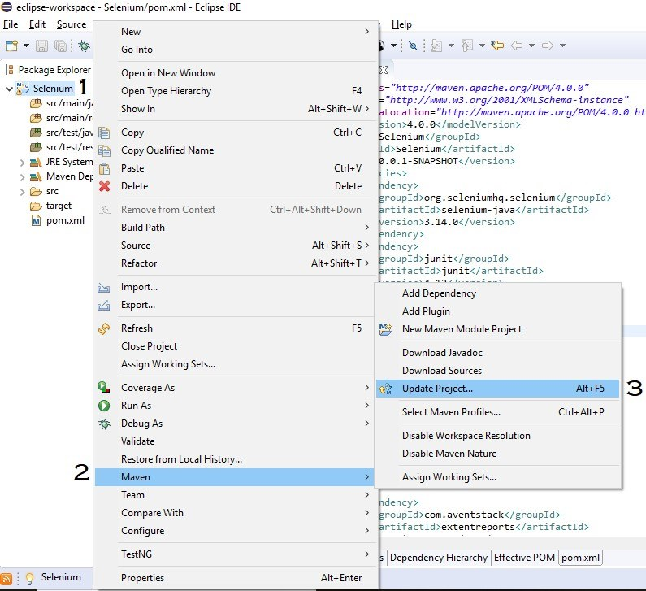

In the Update Maven Project Wizard box check the **force update** and click **ok**.

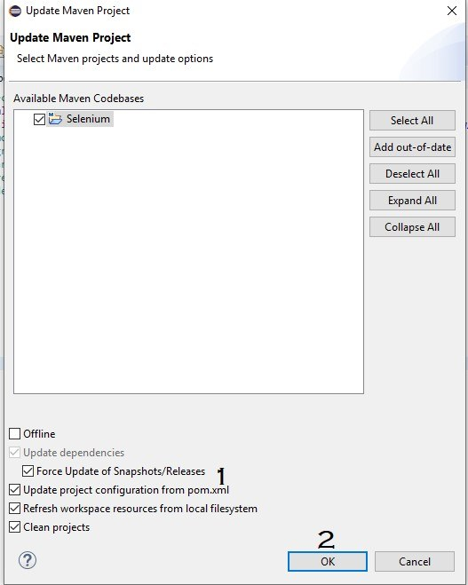

• Now, wait till the project updates itself then you can notice **Maven Dependencies**

Now, wait till the project updates itself then you can notice **Maven Dependencies** in the Project Explorer which contains all the dependencies .jar files.

Once done close the eclipse.



YOU ARE ALL SET TO LEARN JAVA AND SELENIUM! THANK YOU

[Made with Microsoft Sway](https://www.office.com/)